Young Emmets Dominate Coleraine Qualifier
Our 2011 under 12 team made their seasonal debut today in Coleraine for the first round of this year’s indoor hurling tournament. There were six teams at the Coleraine venue, all jockeying for divisional places in next week’s qualifiers.
We began the day by easily sweeping aside the challenges of Owen Roe and Buncrana. The defence kept two clean sheets and our youngest member of the panel, Thomas ‘wreckit’ Scally opened his account with a great strike. The rest of the side were getting nicely into their stride even though some of the lads were suffering blisters following on from a tough training session midweek.
Third match was against last year’s winners, the formidable Glenshesk team. After a tough start Niall Mc Cormick soon dominated defence and was getting the ball moved quickly into the attacking area. David Kilgore and Conor Mc Hugh were having a tough match with their midfield opponents, eventually the ball broke to young Scally who found the corner of the net with a rasping drive. This goal sparked Glenshesk into life and they soon equalised with a fine effort giving James Morgan in goal no chance. David Kilgore then cut loose and finished the contest with two quick strikes. He was replaced by Jack Mc Kay who made an instant impact by wrapping the game up with a fine goal. 4-1 final result.
We were now looking good after 3 wins on the bounce. Next up was Swatragh. This was a game which we dominated from the start and it turned out to be a master class in finishing from Jack ‘Flash’ Mc Kay. He scored four goals; one was a superb overhead double which brought great acclaim from the sidelines from all teams. He then scored a goal that was bizarre as well as super skilful, while changing his stick to a smaller stick near the sideline, he found himself with a stick in each hand when the ball came to him, he casually flicked his wrist and sent the sliothar to the back of the net, fantastic!! Aidan Dunne, the Tyban terrier, played well in this match and set up a lovely goal for Niall Mc Cormick who slotted home from long range. 6 – 0 final score.
Confidence was high as we entered our last game against Donegal Kingpins Burt. A win here would give us a 100% record and guarantee us a place in division one next week.. Conor ‘soft hands’ Mc Hugh was fired up from the start and shot in from a narrow angle to give us the lead. A mistake in defence lead to a penalty for Burt. James Morgan in goal dived sharply to his left to make a super save. This inspired our team to try and maintain a clean sheet. Jack again found the goal twice even though the Burt keeper was in terrific form making a series of acrobatic saves from Aiden Dunne. David Kilgore finished the days scoring and victory was ours on another 6-0 score line.
We remained unbeaten all day and we should now be assured of our place in next week’s division 1 qualifiers. We had a super team performance from everyone today. There will be another tough training session on Thursday lads, so make sure you are all at the hall ready to go at 7.00 with plenty of plasters!!!
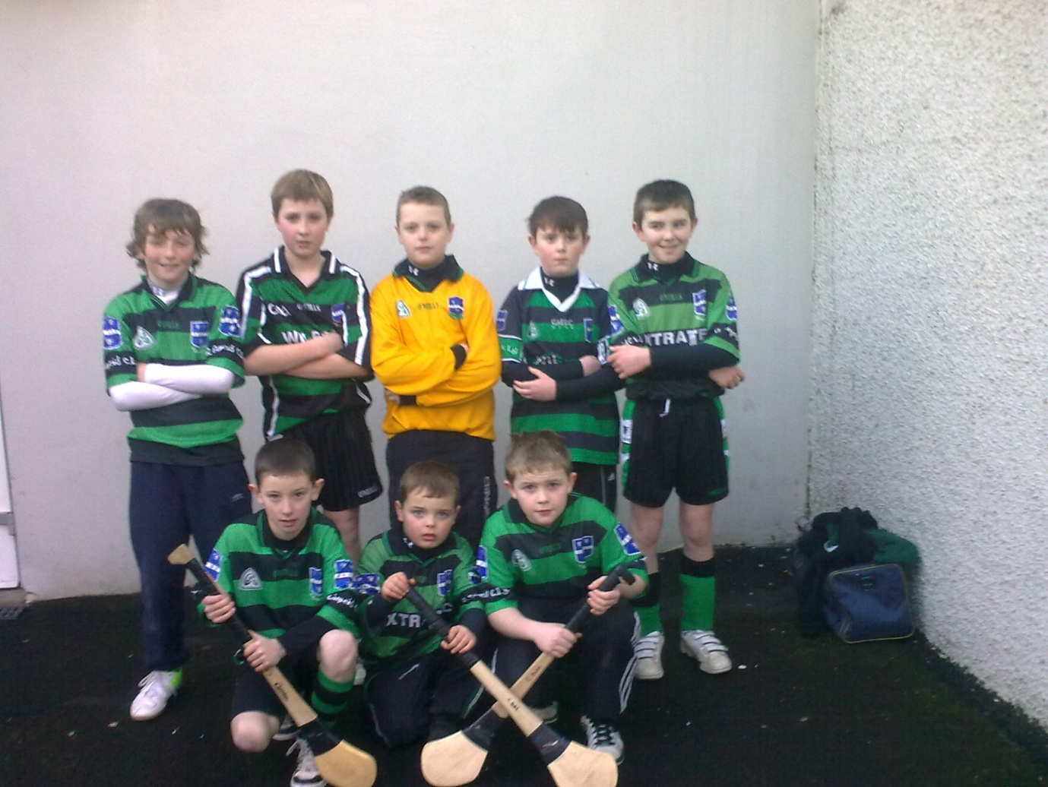

Back Row L-R Niall Mc Cormick, David Kilgore, James Morgan, Thomas Scally, Conor Mc hugh
Front Row L-R Jack Mc Kay, John V Morgan (Physio), Aiden Dunne

